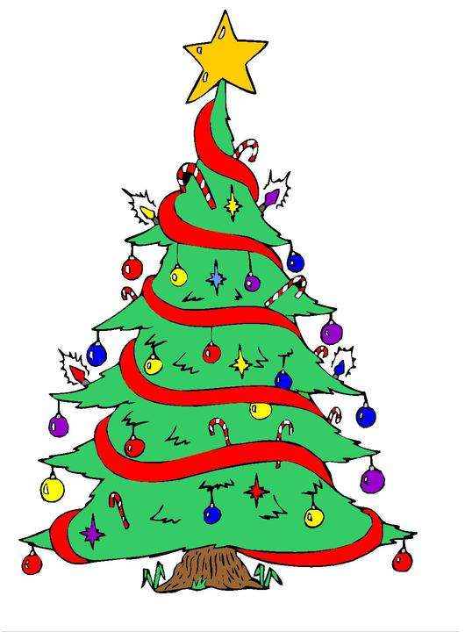
 |  | How many words can you make out of Christmas tree?
 |  | C H R I S T M A S T R E E
 |  |  | ___________ |  | ___________
 |  |  | ___________ |  | ___________
 |  |  | ___________ |  | ___________
 |  |  | ___________ |  | ___________
 |  |  | ___________ |  | ___________
 |  |  | ___________ |  | ___________
 |  |  | ___________ |  | ___________
 |  |  | ___________ |  | ___________
 |  |  | ___________ |  | ___________
 |  |  | ___________ |  | ___________
 |  |  | ___________ |  | ___________
 |  |  | ___________ |  | ___________
Did you find? |  |  |  |  | 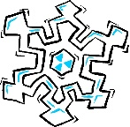
 | Something you wear.  Something you drink.  Something you drive.  Something you breathe.  Something to put on the tree.  A number.  A planet.  A subject in school.  A month of the year.  What a teacher does.  Someone who paints. |  | A place where you sit.  A place where you drive.  A place where you go up.  Another word for clever.  The opposite of stand.  Mix milk in your coffee.  Three of your senses.  A small river.  A group of athletes.  Bonus: Can you find four verbs with both past and present tenses?

